Emotion-Aware User Interface System

A Course Project Report
Submitted in the partial fulfillment of the completion of the course
25CAI302SC507- Human-Computer Interaction and Design
In I Year II Semester M.Tech- CSE
Submitted by
Viquar Fathima
2503B05105
Rehana Tabassum
2503B05103
Zoya Shafeen
2503B05110

Under the supervision of the faculty
Mr. Bediga Sharan
Assistant Professor, CSE
Academic Year: 2025–2026



Department of Computer Science and Artificial Intelligence
SR University Warangal, Telangana, India.

INDEX

- Introduction 1

- Problem Statement 3

- Methodology / Procedure

- Implementation/Code

- Output Screens

- References

Introduction
In recent years, digital transformation in education has significantly increased the adoption of online examination systems. These platforms provide flexibility, scalability, and accessibility, allowing institutions to conduct assessments efficiently. However, despite these advantages, a major challenge faced by students during online exams is stress and anxiety, which can negatively impact their performance, concentration, and overall user experience.
Stress during examinations may arise due to various factors such as time pressure, difficult questions, unfamiliar interfaces, lack of feedback, and fear of evaluation. Traditional online exam systems are typically static and uniform, meaning they present the same interface, difficulty level, and time constraints to all users regardless of their individual emotional or cognitive state. This “one-size-fits-all” approach often fails to accommodate diverse student needs and can increase cognitive load, leading to reduced efficiency and performance.
Human-Computer Interaction (HCI) research emphasizes the importance of designing systems that are user-centered and adaptive. An adaptive interface can dynamically modify its behavior and presentation based on user interactions and context. In the context of online examinations, incorporating adaptability can significantly enhance usability and create a more supportive environment for students.
This project introduces an Adaptive Exam Interface Based on Student Stress, which aims to detect and respond to the stress levels of students in real time. The system analyzes various behavioral indicators such as response time, answer patterns, navigation behavior, and interaction speed. Additionally, optional inputs like facial expressions or physiological signals (if available) can further improve stress detection accuracy.
Based on the detected stress level (low, moderate, or high), the interface intelligently adapts in multiple ways. These adaptations may include:
- Adjusting the visual design using calming color schemes
- Providing motivational messages or hints
- Modifying question difficulty or sequence
- Allowing flexible time management
- Simplifying the interface layout to reduce cognitive load
Such dynamic adjustments help in maintaining student engagement, reducing anxiety, and improving decision-making during exams.
The proposed system not only enhances the user experience but also contributes to fairer assessment practices by considering the emotional well-being of students. By integrating principles of HCI, adaptive systems, and basic artificial intelligence, this project aims to create a more personalized, intelligent, and supportive examination environment.
Ultimately, the goal of this project is to bridge the gap between technology and human emotion by designing an exam interface that is not only functional but also empathetic to the needs of its users.

Problem Statement
With the rapid growth of online education, digital examination platforms have become a standard method for assessing student performance. While these systems offer convenience and scalability, they often fail to address a critical factor affecting student outcomes—psychological stress and anxiety.
Most existing online exam systems are designed with a static and generalized interface, which assumes that all students have similar cognitive abilities, emotional states, and interaction behaviors. However, in reality, students differ significantly in terms of stress tolerance, learning pace, and problem-solving approaches. This mismatch between system design and user needs leads to several challenges.
Limitations of Current Systems
- No Stress Environment
Current systems do not detect or respond to the emotional state of students. High stress levels can lead to poor concentration, increased errors, and reduced performance.
- Uniform Interface Design:
All students are presented with the same layout, color scheme, and navigation structure, regardless of their comfort level or preferences.
- Rigid Time Constraints:
Fixed time limits increase pressure, especially for students experiencing anxiety, leading to rushed decisions and incomplete answers.
- High Cognitive Load:
Complex layouts, lack of guidance, and overwhelming information can increase mental effort, making it harder for students to focus.
- Lack of Personalization:
There is no mechanism to adapt question difficulty, provide hints, or adjust the interface based on individual performance or behavior.
- Poor User Experience:
The absence of interactive and supportive features results in a less engaging and sometimes frustrating exam environment.

Core Problem
There is a need for an intelligent system that can bridge the gap between user emotion and system behavior. The challenge lies in designing an exam interface that is not only functional but also responsive to the psychological state of the user.
Objective of the Problem
The main objective is to create a system that:
- Monitors student interaction patterns continuously
- Identifies stress indicators effectively
- Applies adaptive techniques to modify the interface
- Ensures a balanced and supportive examination experience
Significance of the Problem
Solving this problem is important because:
- It enhances student well-being during exams
- Leads to more accurate performance evaluation
- Promotes user-centered design in educational systems
- Bridges the gap between Human-Computer Interaction (HCI) and Artificial Intelligence (AI)

Methodology / Procedure
The proposed system follows a structured approach to monitor student behavior, detect stress levels, and dynamically adapt the exam interface in real time. The methodology is divided into four major stages: Data Collection, Stress Detection, Interface Adaptation, and Feedback System.
Step 1: Data Collection
The first step involves collecting real-time data based on student interaction with the exam interface. This data helps in understanding user behavior and identifying patterns that may indicate stress.
Types of Data Collected:
- Mouse Movement:
Tracks cursor speed, sudden movements, and hesitation. Rapid or erratic movements may indicate anxiety or confusion.
- Typing Speed:
Measures how fast a student types answers. Very slow or unusually fast typing may indicate stress or lack of confidence.
- Response Time:
Records the time taken to answer each question. Increased response time may indicate difficulty or cognitive overload.
- Question Skipping Frequency:
Tracks how often a student skips questions or switches between them. Frequent skipping may indicate uncertainty or stress.
Purpose:
This step provides raw behavioural data that serves as input for stress analysis.
Step 2: Stress Detection
In this stage, the collected data is analyzed using basic Artificial Intelligence or rule-based logic to determine the student’s stress level.
Process:
- Data from Step 1 is processed and compared against predefined thresholds
- Patterns such as delays, rapid navigation, or inconsistent behavior are identified
- A stress score is calculated for each student
Stress Classification:
Based on the analysis, students are categorized into:
- Low Stress:
Normal interaction, steady response time, minimal errors
- Medium Stress:
Slight delays, moderate hesitation, occasional question skipping
- High Stress:
Frequent skipping, long delays, erratic interaction patterns
Purpose:
To continuously monitor and classify the emotional state of the student during the exam.
Step 3: Interface Adaptation
Based on the detected stress level, the system dynamically adjusts the exam interface to improve user comfort and performance.
Adaptation Techniques:
- UI Color Adjustment:
Switch to calming colors (e.g., blue or green) when high stress is detected to create a relaxed environment
- Difficulty Adjustment (Optional):
Modify question sequence or provide slightly easier questions to maintain confidence
- Motivational Prompts:
Display encouraging messages like “You’re doing well, stay calm!”
- Time Adjustment:
Provide additional time or flexible timing when stress levels are high
- Layout Simplification:
Reduce clutter, highlight key elements, and enable focus mode
Purpose:
To reduce anxiety, improve concentration, and create a personalized exam experience.
Step 4: Feedback System
After the exam, the system provides detailed feedback to help students understand their performance and behavior.
Features:
- Performance Insights:
Displays scores, accuracy, and time taken per question
- Stress Analysis Report:
Shows when the student experienced stress during the exam
- Suggestions for Improvement:
Recommends strategies such as time management tips or practice areas
- User Experience Feedback:
Allows students to share their experience with the adaptive system
Purpose:
To support learning, improve future performance, and enhance system effectiveness.

Implementation
The implementation of the Adaptive Exam Interface Based on Student Stress involves designing an interactive system that integrates user interface design, real-time data processing, and adaptive logic. The system is developed using modern web technologies and design tools to ensure usability, responsiveness, and scalability.
4.1 Tools Used
1. Figma (UI/UX Design)
- Used for designing interactive prototypes of the exam interface
- Helps visualize:
  - Login screen
  - Exam dashboard
  - Adaptive UI changes based on stress
- Enables user flow design and usability testing before development
2. HTML, CSS, JavaScript (Frontend Development)
- HTML:
Structures the web pages (forms, buttons, questions, layout)
- CSS:
Styles the interface (colors, fonts, spacing, responsive design)
- JavaScript:
Handles:
  - User interactions
  - Event tracking (mouse, typing, clicks)
  - Dynamic UI updates (real-time adaptation)
3. Python / Machine Learning (Optional)
- Used for stress prediction logic
- Implements simple models such as:
  - Rule-based classification
  - Basic ML algorithms (e.g., Decision Tree, Logistic Regression)
- Processes user behavior data and outputs stress level
4.2 System Modules
The system is divided into the following functional modules:
1. Login Module
- Allows students to securely log in using credentials
- Validates user information
- Redirects to exam dashboard
Features:
- Username & password authentication
- Simple and clean UI
- Error handling for invalid login
2. Exam Dashboard
- Main interface where students take the exam
Components:
- Question display panel
- Timer
- Navigation panel (Next, Previous, Skip)
- Progress indicator
Function:
- Displays questions dynamically
- Tracks user responses and interactions
3. Stress Detection Module
- Core module responsible for identifying student stress
Working:
- Collects data such as:
  - Response time
  - Mouse movement
  - Question switching
- Applies logic or ML model to calculate stress level
Output:
- Low Stress
- Medium Stress
- High Stress
4. Adaptive UI Engine
- Adjusts the interface based on detected stress level
Adaptation Examples:
- Change background colors to calming tones
- Simplify layout during high stress
- Provide motivational pop-ups
- Adjust time or question flow
Technology Used:
- JavaScript for real-time UI updates
- CSS for dynamic styling
5. Result & Feedback Module
- Displays exam results and analysis after completion
Features:
- Score and accuracy
- Time analysis
- Stress level report
- Suggestions for improvement
4.3 Key Features of the System
1. Real-Time UI Changes
- Interface updates instantly based on user behavior
- Enhances responsiveness and interactivity
2. Personalized Exam Experience
- Each student gets a customized interface
- Adapts according to individual stress level
3. Stress-Aware Notifications
- Displays alerts like:
  - “Take a deep breath”
  - “You’re doing great!”
- Helps reduce anxiety during exams
4. Smart Question Navigation
- Allows easy switching between questions
- Highlights unanswered questions
- Suggests next question based on behavior
4.4 Implementation Workflow
- User logs into the system
- Exam dashboard is loaded
- User interaction data is continuously captured
- Stress detection module analyzes behavior
- Adaptive UI engine modifies interface in real time
- After exam, results and feedback are displayed

Output Screens
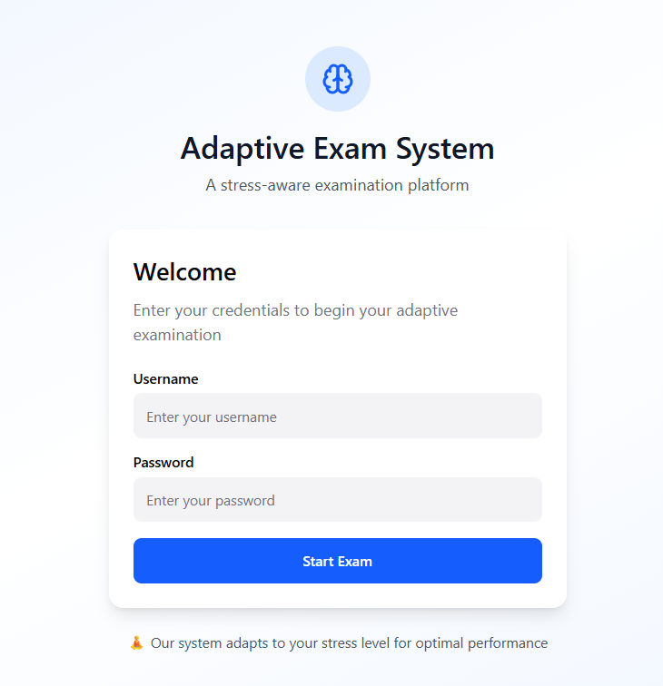

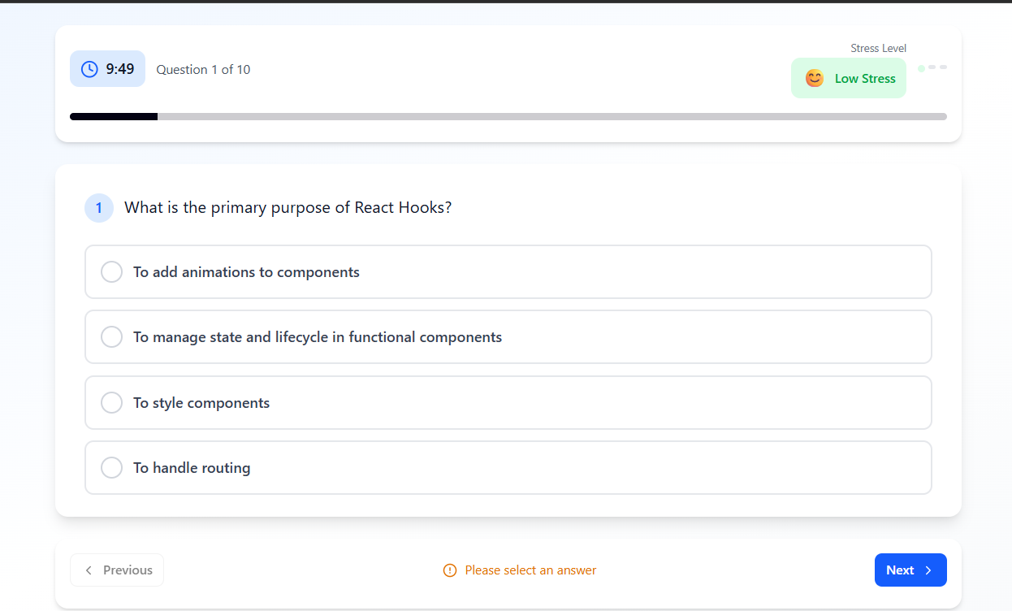
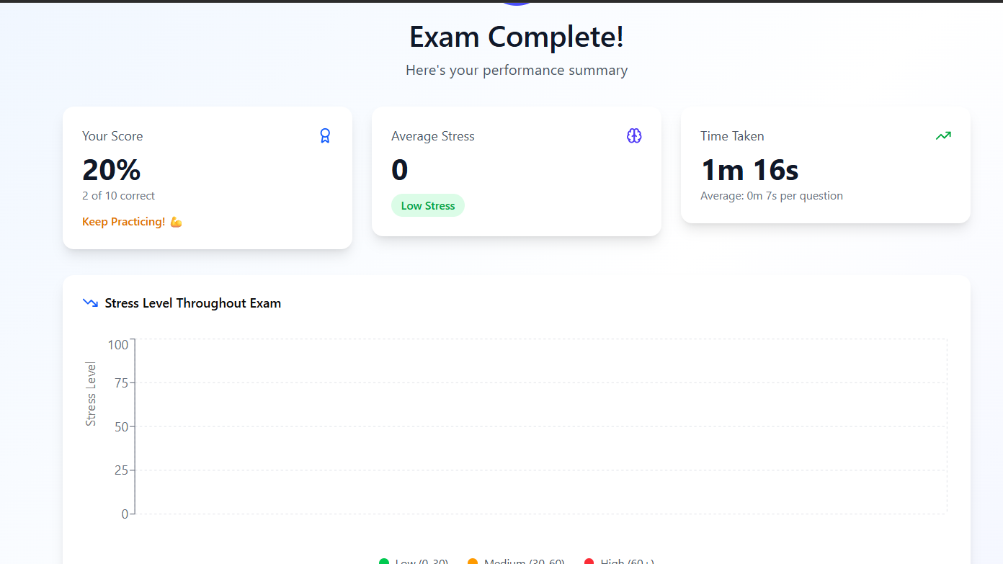

References

- Human-Computer Interaction – Alan Dix
- Research papers on Emotion-Aware Systems
- Online resources on Adaptive UI Design
- Figma Documentation
- AI-based User Behavior Analysis articles

